**Academic Experience:**

**University at Albany: Albany, NY August 2018 – Present**

Bachelor of Arts – Journalism & Film

**Honors:**

* Dean’s List of Distinguished Students (3.6 GPA)
* National Society of Collegiate Scholars

**Relevant Experience:**

**Broadcast Journalism (Class) January 2021 – May 2021**

Wrote, record, and produced a variety of television and radio news stories with a degree of professionalism resembling what might be found in local newscasts

**Online Publishing (Class) August 2021 – December 2021**

Completed journalism projects which include video, photography, and editing.

**Work Experience:**

**Content Creator (YouTube) June 2020 – Present**

Video content creation amassing over 30k+ subscribers, experienced with the following: video editing, script writing, narration, and social media management.

**Carpenter Apprentice (Gallego Construction - Ossining, NY)** **March 2021 – August 2021**

Worked as an apprentice doing the following: installed over 15 cabinets and shelves, painted over 20 walls, installed over 30 door handles, locks, and hinges.

**Skills:**

* 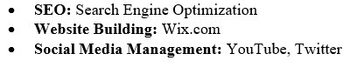**Video Editing/Production**: Sony Vegas Pro
* **Audio Recording**: Audacity, Elgato Wave 3
* **Filming:** Sony Alpha 6600